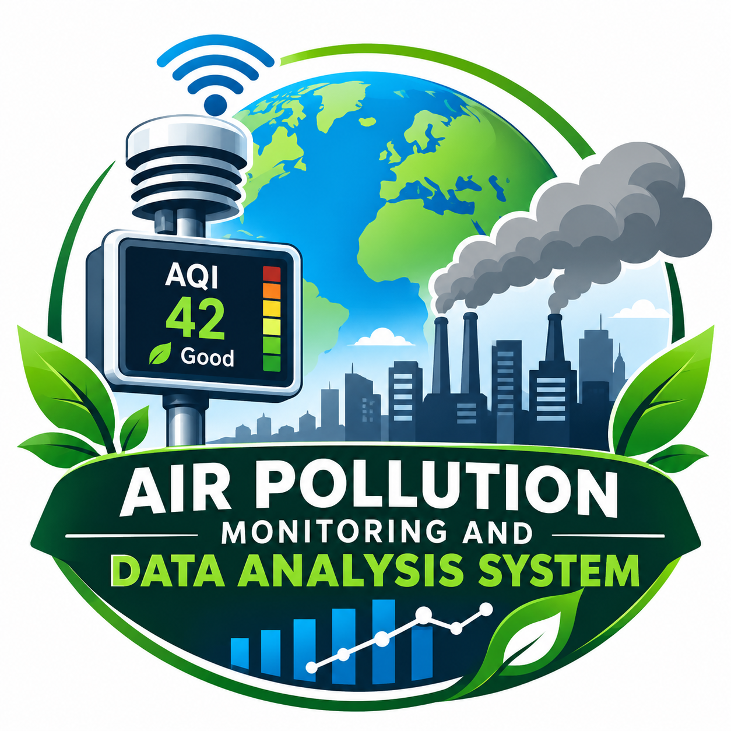PROJECT PROPOSAL
Project Title: Air Pollution Monitoring and Data Analysis System
1. Introduction
Air pollution is one of the major environmental problems affecting human health and the environment. It is mainly caused by vehicle emissions, industrial activities, burning of waste, and construction activities.
This project aims to study air pollution levels using data analysis techniques. It helps identify pollution levels in different cities and understand how air quality changes over time.
2. Problem Statement
Air pollution is increasing day by day due to human activities. People are often unaware of the pollution levels in their surroundings.
There is a need for a system that collects, cleans, analyzes, and presents pollution data to understand air quality and identify highly polluted areas.
3. Objectives
- To collect air pollution data from different cities.
- To clean and organize the pollution dataset.
- To analyze Air Quality Index (AQI) levels.
- To identify highly polluted and less polluted areas.
- To represent pollution data using graphs and charts.
- To create awareness about air pollution and its effects.
4. Proposed Solution
We propose an Air Pollution Monitoring and Data Analysis System using Python.
The system will use pollution datasets containing AQI and other air pollution measurements. Python libraries will be used to clean, process, analyze, and visualize the data.
The results will help users understand pollution trends and compare air quality between different cities.
5. Tools and Technologies
- Programming Language: Python
- Libraries: Pandas, NumPy, Matplotlib, Seaborn
- Platform: Jupyter Notebook / VS Code
- Dataset: Air Pollution Dataset (Excel)
- Visualization: Graphs, charts, and dashboards
6. Methodology
- Data Collection: Collect air pollution data from different cities.
- Data Cleaning: Remove duplicate records, handle missing values, and correct data formats using Pandas.
- Data Processing: Organize the data and calculate useful statistics.
- Data Analysis: Analyze AQI levels and identify pollution patterns.
- Data Visualization: Create graphs and charts to represent pollution levels.
- Result Generation: Prepare a report based on the analysis.
7. Expected Outcomes
- A cleaned and organized pollution dataset.
- City-wise pollution comparisons.
- Identification of areas with high pollution levels.
- Graphical representation of AQI values.
- Better understanding of pollution trends.
- Increased awareness about environmental protection.
8. Benefits of the Project
- Helps understand air pollution levels.
- Supports environmental awareness.
- Makes pollution data easier to understand.
- Helps identify pollution trends.
- Encourages people to adopt eco-friendly practices.
9. Future Scope
- Develop a real-time air pollution monitoring dashboard.
- Integrate live AQI data from monitoring sources.
- Add location-based pollution information.
- Use machine learning to predict future pollution levels.
- Develop a mobile application for pollution alerts.
10. Conclusion
The Air Pollution Monitoring and Data Analysis System aims to make pollution data easier to understand through Python and data visualization. It helps identify pollution patterns and creates awareness about the importance of clean air. This project can be further developed into a real-time monitoring and prediction system.
Project Goal: To analyze air pollution data and support a cleaner and healthier environment.

